Week 7

Q.1). Create a Pandas Series from a list and a DataFrame from a dictionary.
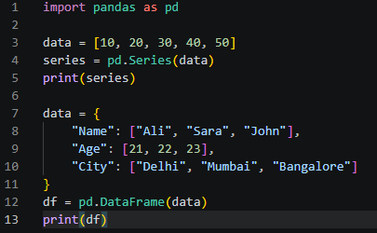
Output
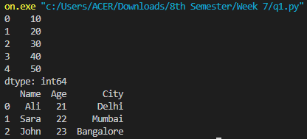
Q.2). Load a CSV file and display the first five rows and display head, tail, and info of a dataset.
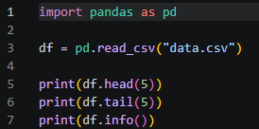
Output
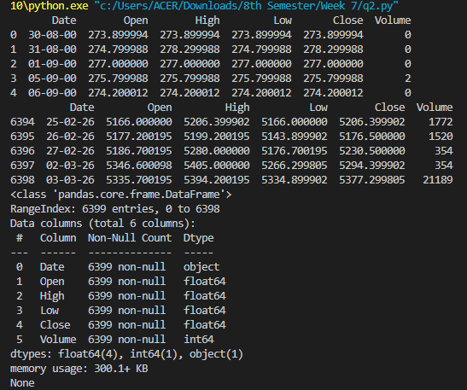
Q.3). Take a DataFrame and do the following:
- What is the average value of the second column?
- What is the average value of the first 5 rows of the third and fourth columns?
- Compute the row wise sum of all possible values in an array.
- Find the maximum of average value in each row.
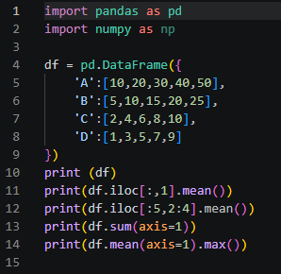
Output
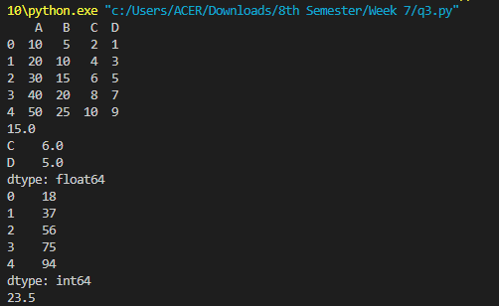
Problems Based on HTML and JavaScript
Q.4). Write a program to display a multiplication table.
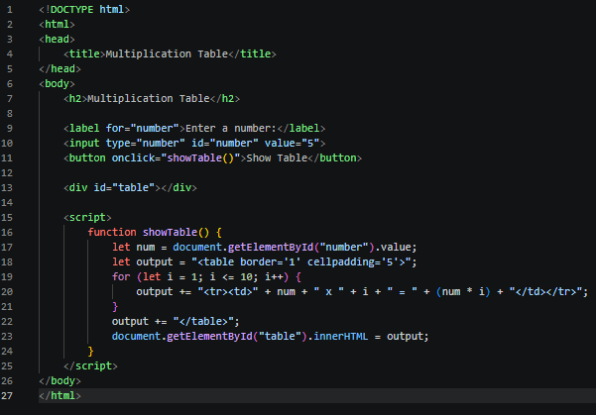
Output
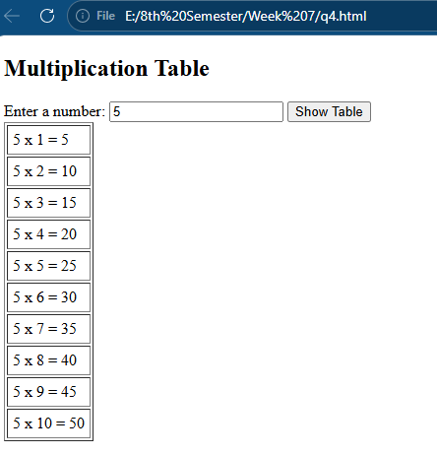
Q.5). Create a Web page using two image files, which switch between one another as the mouse pointer moves over the image. Use the On Mouse over and On Mouse out event handler.
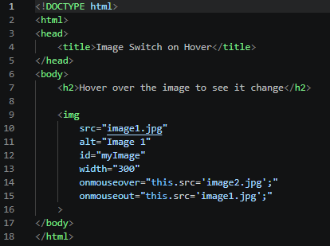
Output
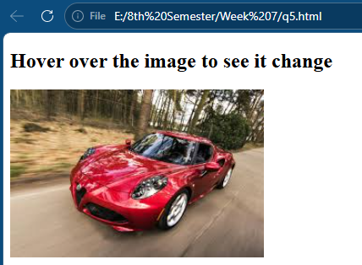
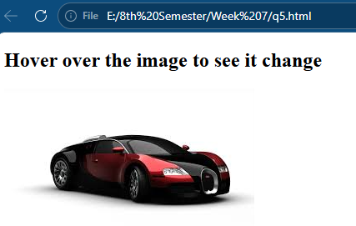

Q.6). Use the date function gets Date & set Date to prompt the user for an integer between 1 – 31 & return day of the week it represents.
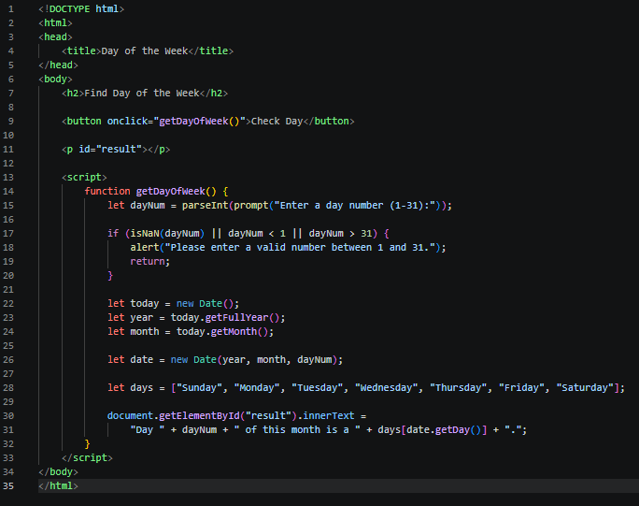
Output
